REPORT ON

AI Generated Adaptive Quiz & Learning Platform

Submitted by
Kapsi Mohammed Aftab
MCA
(Cyber Security & Ethical Hacking with Minor in Cyber Forensics)
(Batch: 2024-26)

1. Introduction
Traditional online learning platforms often provide static quizzes that do not adapt to a learner’s performance or provide personalized learning paths. This project introduces an AI-Powered Adaptive Quiz Learning Platform that dynamically generates quizzes using Generative AI and adapts the difficulty level based on user performance.
The platform allows learners to select different courses, attempt AI-generated quizzes, track their progress, and compete on leaderboards. By integrating Artificial Intelligence, modern web technologies, and analytics, the system creates an engaging and personalized learning experience.

2. Problem statement
Develop an innovative learning platform where the curriculum is static but the assessments are “Dynamic.” Use Generative AI to create unique sets of quiz questions every time a user takes a test, ensuring that no two students get the same questions. The AI should manipulate question difficulty based on the user’s progress and previous quiz performance.

3. Objectives
The main objectives of the project are:
- Dynamic Quiz generation and question manipulation.
- Progress tracking with personalized learning paths.
- Support for multiple courses with diverse topic.
- Interactive UI with timers and instant result.

4. System Architecture
The platform follows a client-server architecture.
React Frontend
↓
FastAPI Backend
↓
AI Model (Llama3 via Ollama)
↓
Quiz Generation
↓
Progress Tracking & Analytics

Components
- Frontend (React + TailwindCSS)
  - User interface
  - Quiz interaction
  - Dashboard and analytics
- Backend (Python FastAPI)
  - API endpoints
  - Quiz generation
  - Score evaluation
- AI Model (Ollama + Llama3)
  - Generates quiz questions dynamically
- Progress Storage
  - Stores user quiz results
  - Used for leaderboard and analytics

5. Technologies Used
Technology | Purpose
React.js | Frontend framework
Tailwind CSS | Modern UI design
FastAPI | Python backend API
Ollama | Local AI model runner
Llama3 | Large Language Model for quiz generation
Axios | API communication
Recharts | Progress analytics visualization

6. System Features
6.1 AI-Generated Quiz Questions
The system uses a Large Language Model (Llama3) through Ollama to dynamically generate quiz questions.
Example prompt sent to AI:
Generate 3 multiple choice quiz questions about Python programming.
Difficulty: medium
Return JSON with question, options, and answer.
This ensures that each quiz attempt produces unique questions.

6.2 Multiple Course Support
The platform supports multiple subjects including:
- Python Programming
- Cyber Security
- Artificial Intelligence
- Data Structures

6.3 Adaptive Learning
The system adjusts difficulty based on user performance.
Example logic:
Score < 50% → Easy questions
Score 50–80% → Medium questions
Score > 80% → Hard questions
This creates a personalized learning path.

6.4 Interactive Quiz Interface
The quiz interface includes:
- Timer-based quizzes
- Modern UI with option highlighting
- Navigation between questions
- AI loading animation while generating questions

6.5 Progress Tracking Dashboard
The system tracks user performance across quizzes and visualizes it through a dashboard.
Metrics include:
- Score percentage
- Course performance
- Learning progress

6.6 Leaderboard
The leaderboard ranks users based on quiz performance.
Features:
- Sorted score ranking
- Course-based leaderboard
- Real-time updates after quiz submission

7. User Interface Design
The frontend is built using React and TailwindCSS, providing a modern and responsive design.
Main UI sections include:
- Login / Registration
Login page


Registration page

- Course Dashboard
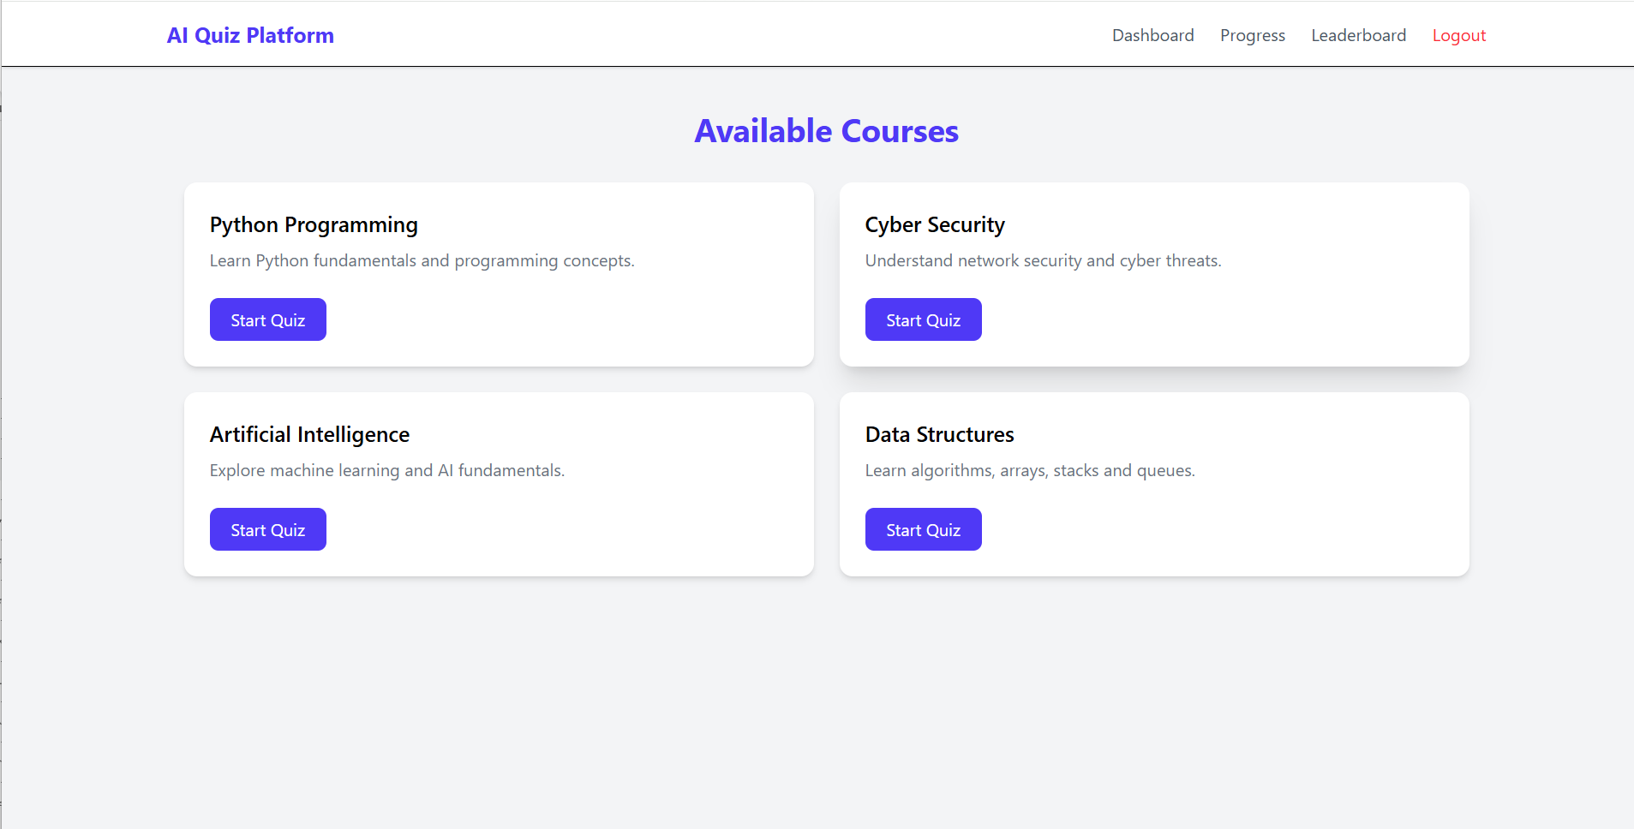
- Quiz Interface
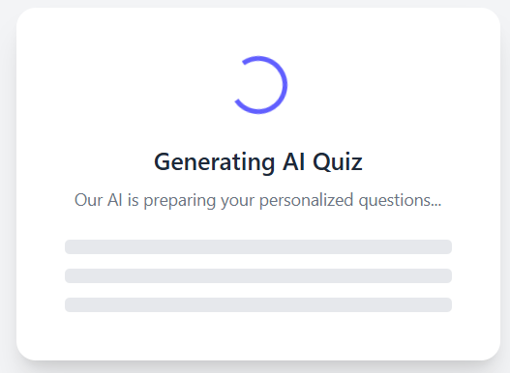

Quiz question page
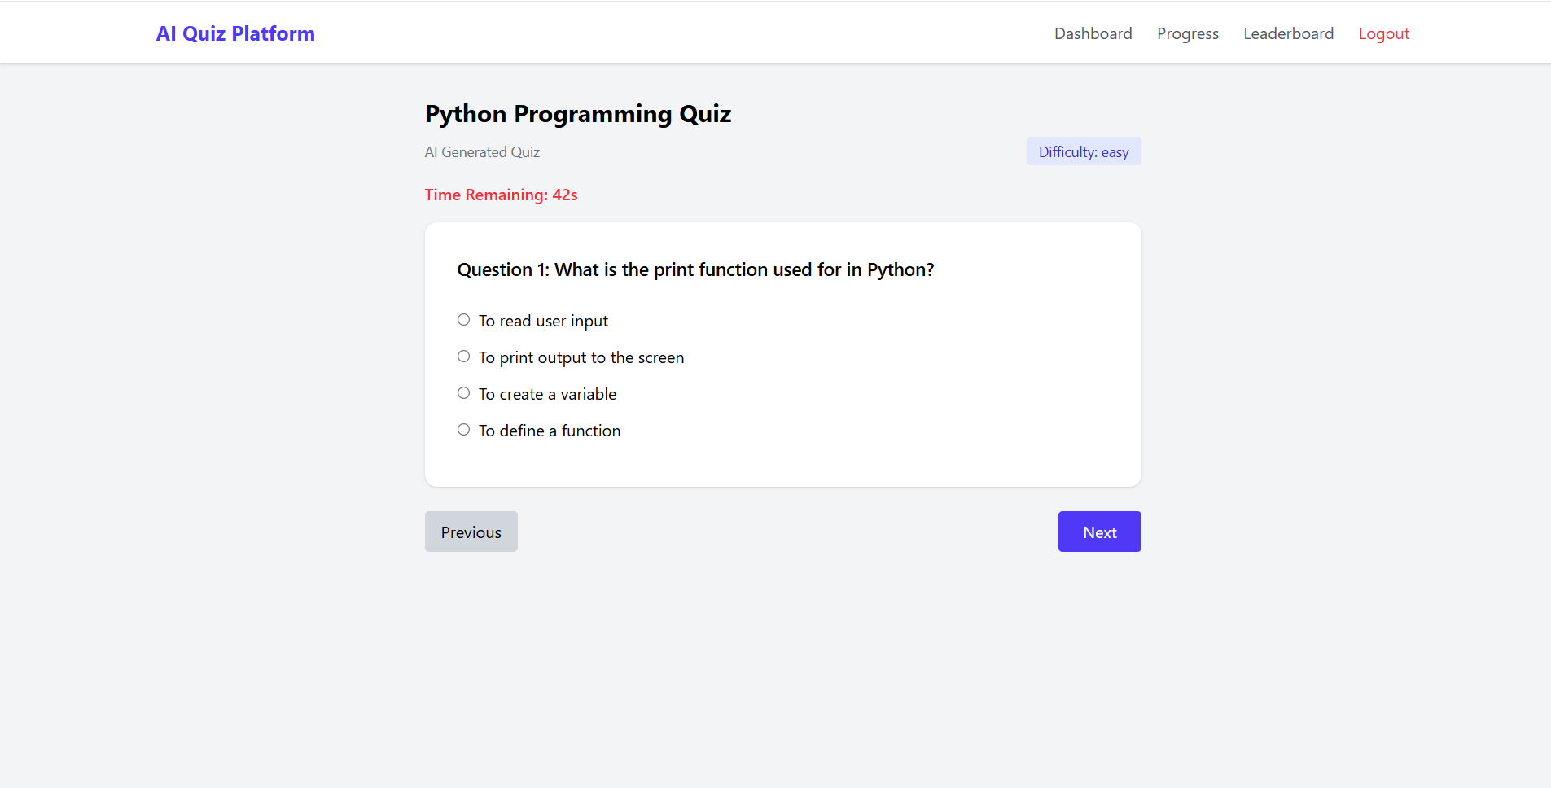

Quiz result page
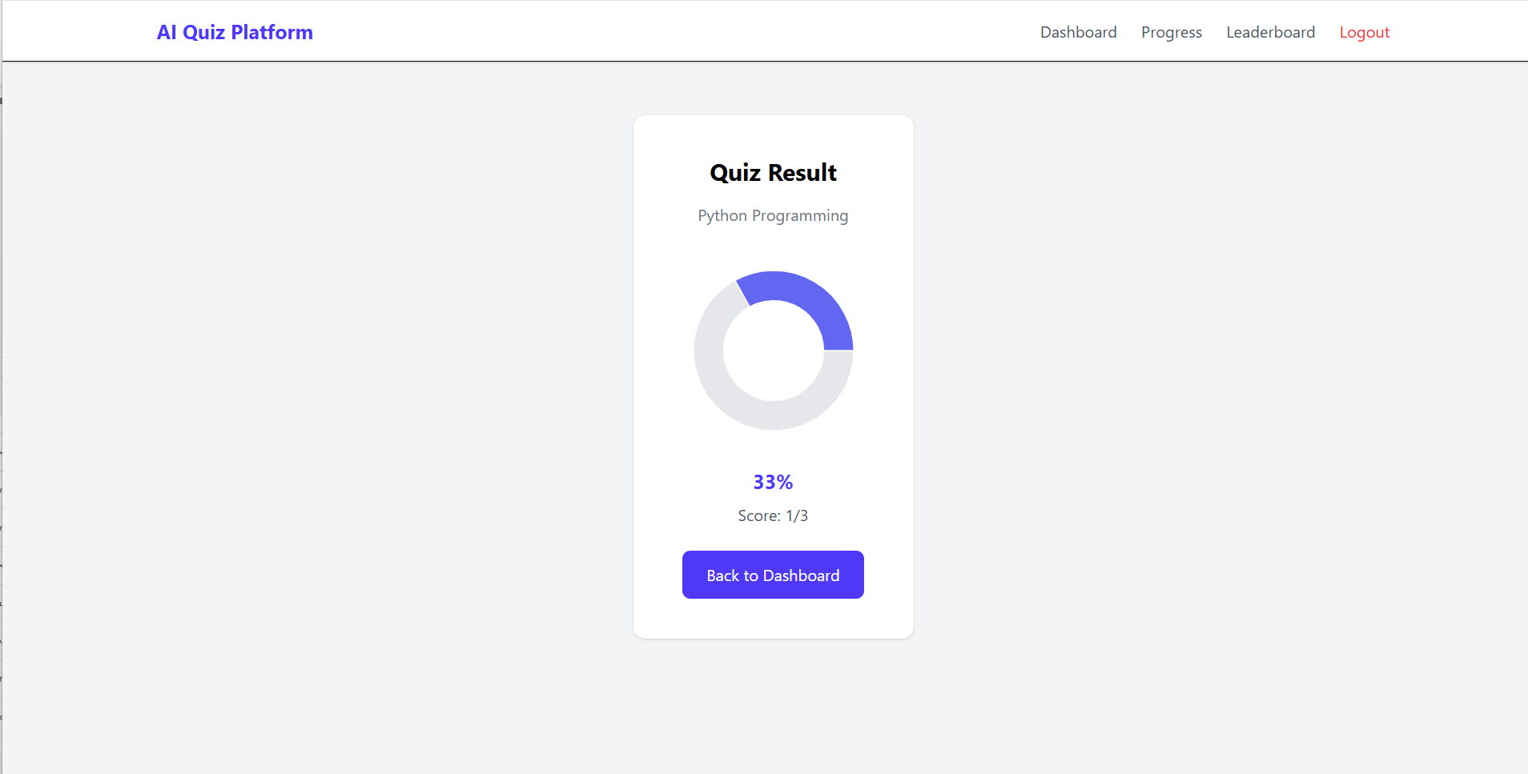

- Progress Dashboard
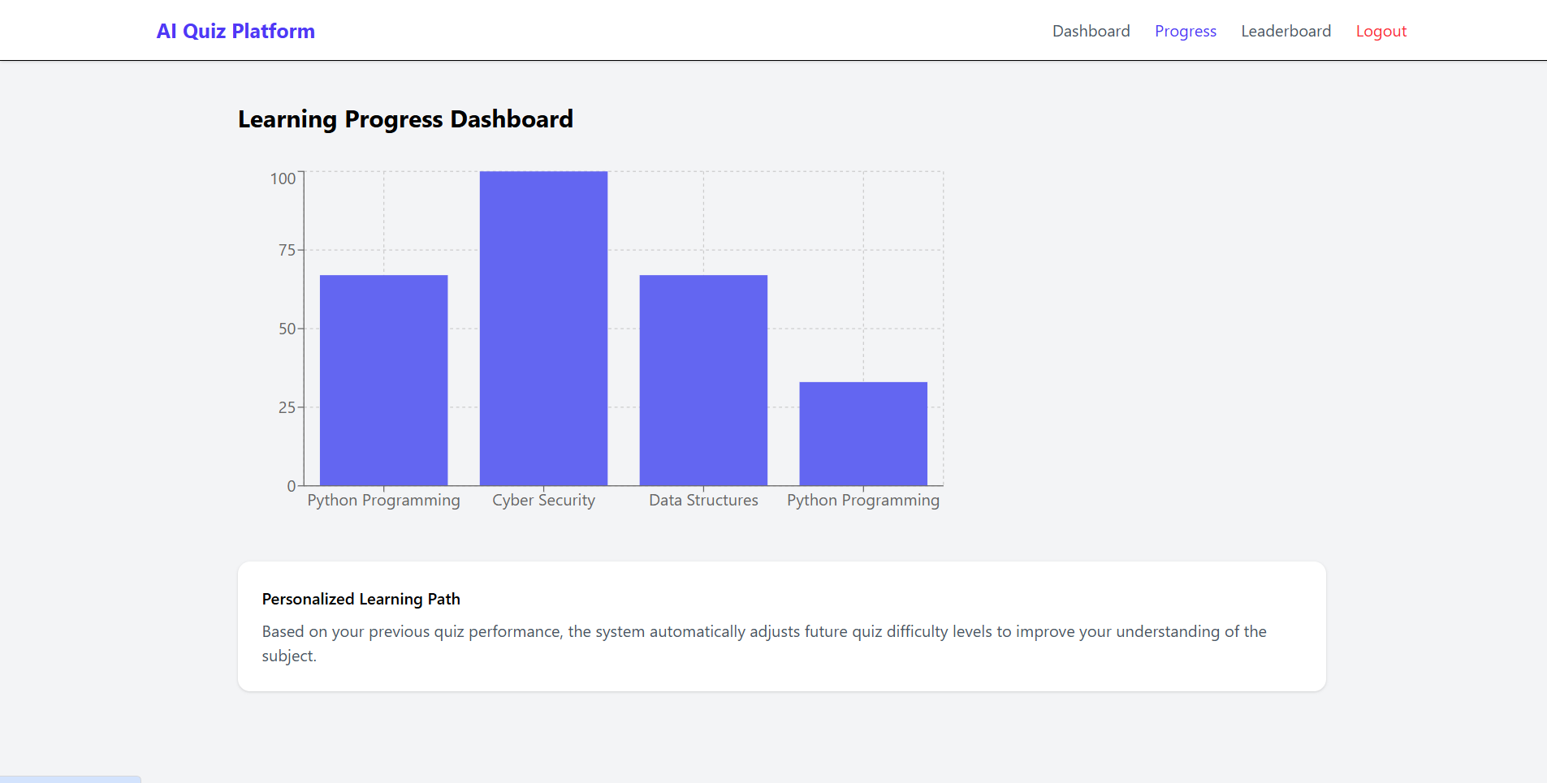
- Leaderboard
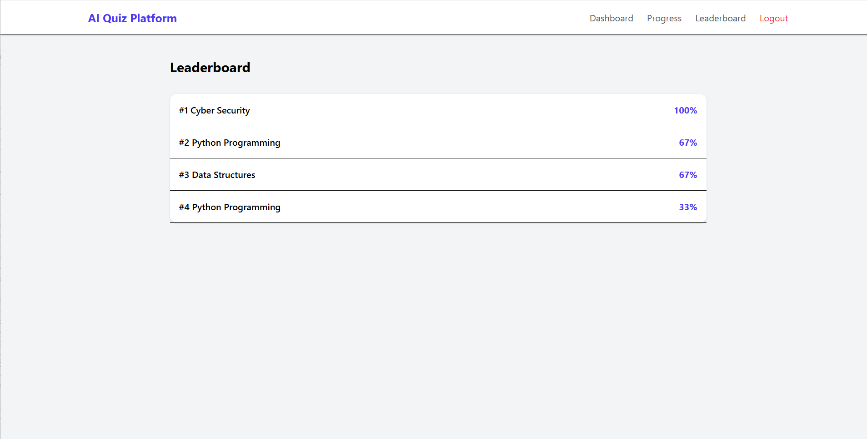

8. Workflow
User Login
↓
Select Course
↓
Backend sends prompt to AI
↓
AI generates quiz questions
↓
Quiz displayed to user
↓
User submits answers
↓
Backend calculates score
↓
Progress stored and displayed

9. Advantages
- Personalized learning experience
- Unlimited AI-generated quizzes
- Interactive and engaging UI
- Real-time performance tracking
- Scalable architecture

10. Limitations
- AI response time may vary
- Requires local AI model setup
- Limited dataset for leaderboard (prototype stage)

11. Future Improvements
Possible enhancements include:
- User authentication with database
- Course recommendation system
- Difficulty prediction using machine learning
- Real-time multiplayer quiz mode
- Cloud deployment

12. Conclusion
The AI-Powered Adaptive Quiz Learning Platform demonstrates how generative AI can enhance educational systems. By combining modern web technologies, AI-driven content generation, and analytics dashboards, the system provides an intelligent learning environment that adapts to user performance.
This project showcases the potential of AI-assisted learning platforms in improving engagement, personalization, and knowledge retention.

